|  |  |  |  |  |  |  |
| --- | --- | --- | --- | --- | --- | --- |
| Description: Vertical full colour positive | Safety Bay Senior High School | | | | | |
| **CHEMISTRY UNIT 3 & 4** | | | | | | |
| **Test #5:** | | | | | | |
| **Organic Chemistry** | | | | | | |
|  | | | | | | |
| **NAME:** | | |  | | | |
|  | | |  | | | |
| **Time allowed for this paper** | | | | | | |
| Reading time: | | 5 minutes | | | | |
| Working time: | | 50 minutes | | | | |
|  | | | | | | |
| **Structure of this paper:** | | | | | | |
| Section | | | Number of questions | Marks available | | Marks achieved |
| Section One: Multiple Choice | | | 4 | 4 | |  |
| Section Two: Short Answer | | | 8 | 50 | |  |
|  | | |  | | **Total** | ______ / 54 |

**Section One: Multiple Choice**

Answer all questions by circling the correct option. Only circle one option for each question.

1. A student’s study notes on protein structure included these four unlabelled sketches:

|  |  |
| --- | --- |
|  | H  H  H  N  C  C  O  O  H  R |
|  | **I** |
|  | Ala  His  Met  Ala  Pro |
|  | **III** |

**II**

**IV**

1. A student’s study notes on protein structure included these four unlabelled sketches:

|  |  |
| --- | --- |
| H  H  H  N  C  C  O  O  H  R |  |
| **I** | **II** |
| Ala  His  Met  Ala  Pro |  |
| **III** | **IV** |

Which sketches best represent the primary, secondary and tertiary structure of proteins?

|  |  |  |  |
| --- | --- | --- | --- |
|  | **Primary structure** | **Secondary structure** | **Tertiary structure** |
| (a) | I | II | IV |
| (b) | I | IV | II |
| (c) | III | IV | II |
| (d) | III | II | IV |

1. In response to a pain stimulus, the brain produces small polypeptide molecules called enkephalins. These molecules block the transmission of pain through the central nervous system.

The amino acid sequence in one such compound, methionine enkephalin, is:

Tyr – Gly – Gly – Phe - Met

The number of amine, carboxylic acid and amide (peptide) functional groups in this polypeptide is:

|  |  |  |  |
| --- | --- | --- | --- |
|  | **-NH2** | **-COOH** | **-CONH** |
| (a) | 0 | 0 | 5 |
| (b) | 1 | 1 | 4 |
| (c) | 1 | 1 | 5 |
| (d) | 0 | 2 | 4 |

**Section Two: Short Answer**

Write your answers in the spaces provided.

1. **(3 marks)**
   1. What is meant by the term ‘functional group’? (1 mark)

* 1. Complete the table by naming the functional groups labelled A-D. (2 marks)

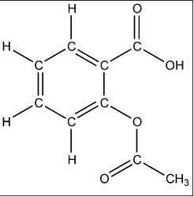

**(A)**

**(B)**

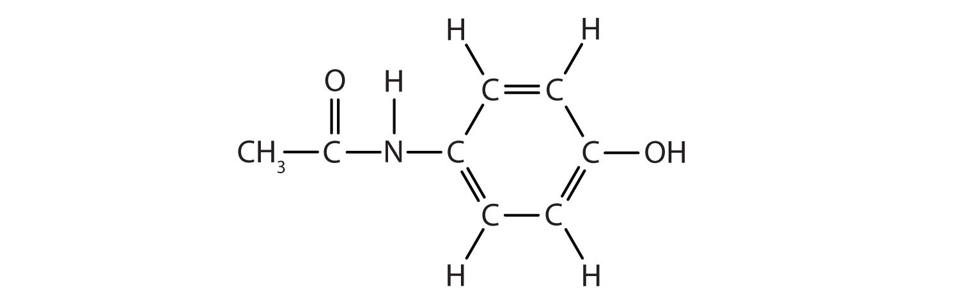

**(C)**

**(D)**

|  |  |
| --- | --- |
| **Label on diagram** | **Name of functional group** |
| A |  |
| B |  |
| C |  |
| D |  |

1. **(6 marks)**

Complete the following table.

|  |  |
| --- | --- |
| **Name** | **Structural formula (showing all atoms)** |
| *cis*-but-2-ene |  |
|  |  |
| 4-methylpentan-2-ol |  |
|  | http://50.19.212.204/resources/models360/files/31272/butyl_acetate-lewis2.png |
| 2-iodobutanoic acid |  |
|  |  |

1. **(5 marks)**

Use structural formulae to show the organic product(s) of the following reactions.

If no reaction occurs, state this clearly.

|  |  |
| --- | --- |
| **Reactants** | **Structure of organic product** |
| CH3CH=CHCH3 + H2O |  |
| CH3CHCH2CH2CH3 + KMnO4  |  OH |  |
| CH3CH2COOCH2CH3 + NaOH |  |
| CH2CHCH2OH + Cℓ2(g) |  |

1. **(6 marks)**

Boiling points of some organic compounds are listed in the table below.

|  |  |  |  |  |
| --- | --- | --- | --- | --- |
| **Compound** | Propan-1-ol | Propanal | Propanone | Propanoic acid |
| **Boiling points (°C)** | 92.7 | 47.9 | 56.1 | 140.8 |

* 1. Why are the boiling points of propan-1-ol and propanoic acid higher than the boiling points of propanal and propanone? (2 marks)

* 1. Which of these compounds would be expected to be most soluble in water? Give reasons. (2 marks)

* 1. Would the expected boiling point of butan-1-ol be greater or less than 92.7 °C (the boiling point of propan-1-ol)? Give reasons. (2 marks)

1. **(10 marks)**

Two different compounds *A* and *B* are isomers with the molecular formula C3H8O.

*A* and *B* undergo a series of reactions as shown below.

*A*

C3H8O

*C*

C3H6O2

*D*

C3H5O2Na

acidified K2Cr2O7

added dropwise

1. NaOH added

2. solution evaporated

*B*

C3H8O

*E*

C3H6O

acidified K2Cr2O7

added dropwise

* 1. Give the structural formulas for C and E. (2 marks)

|  |  |
| --- | --- |
| Structural formula of C | Structural formula of E |

* 1. How is compound *A* different from compound *B*? (1 mark)

* 1. Describe the colour change observed when acidified K2Cr2O7 is added to *A*. (1 mark)

* 1. Write oxidation and reduction half-equations to show the reaction that forms compound *C*. (4 marks)

|  |  |
| --- | --- |
| **Oxidation half-equation** |  |
| **Reduction half-equation** |  |

*B* and *C* can react together in the presence of a small amount of concentrated sulfuric acid to produce *F*.

* 1. Name the type of reaction that occurs between *B* and *C* to from *F*. (1 mark)

* 1. Draw the structural formula of *F*. (1 mark)

1. **(9 marks)**

Phenylalanine (chemical structure shown below) is an essential α-amino acid.

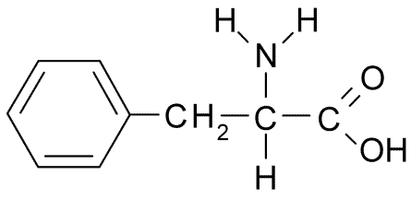

* 1. Why is phenylalanine classified as an **alpha** amino acid? (1 mark)

* 1. In neutral solutions at pH 7, phenylalanine exists as a zwitterion. Draw the structure of the zwitterion form of phenylalanine. (1 mark)

* 1. What evidence is there that solid phenylalanine is comprised of molecules in the zwitterion form? Explain. (3 marks)

* 1. The structure of amino acids is dependent on pH. Draw the structure of the α-amino acid **lysine** under the following pH conditions. *(Refer to your data book for the structure of lysine)* (2 marks)

|  |  |
| --- | --- |
| **pH** | **Structure of lysine** |
| 2 |  |
| 12 |  |

* 1. Draw the structure of a dipeptide formed between phenylalanine and lysine. On your drawing circle and label the ‘peptide bond’. (2 marks)

1. **(5 marks)**

The following screenshot shows the structure of 5EPZ, a human angiogenin protein.

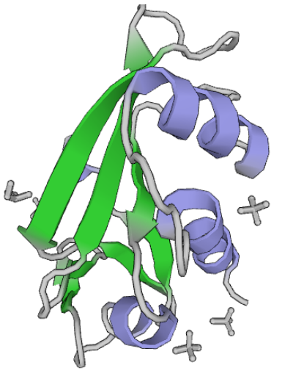

* 1. Label the above diagram by naming the outlined features. (2 marks)
  2. Explain what leads to the formation of the structures shown on the diagram above. (2 marks)

* 1. The image above was sourced from the Protein Data Bank (PDB). Briefly describe the role of the PDB. (1 mark)

1. **(6 marks)**

Myrcene is a naturally occurring compound found in the leaves of bay trees. It is known to be a polyunsaturated hydrocarbon. It can react with hydrogen to produce a saturated hydrocarbon.

In a laboratory investigation, a 1.00 g sample of myrcene fully reacted with exactly 510 mL of hydrogen gas measured as 20.0 °C and 105.0 kPa. In this reaction, myrcene was converted to a saturated alkane with a molecular formula C10H22.

* 1. What type of reaction has occurred between the myrcene and hydrogen? (1 mark)

* 1. Calculate the number of moles of hydrogen reacting. (1 mark)

* 1. Calculate the mass of C10H22 produced in the reaction. (2 marks)

* 1. Determine the number of double bonds in each molecule of myrcene. (2 marks)

**SPARE PAGE**